Detailed Design Change Pack

Communication Detail
Comm Reference: | 3301.1 – LO - PO
Comm Title: | Detailed Design for XRN5616B – CSEP Annual Quantity Capacity Management
Comm Date: | 12/08/2024

Change Representation
Action Required: | For Representation
Close Out Date: | 27/08/2024

Change Detail
Xoserve Reference Number: | XRN5616B
Change Class: | Functional
*ChMC Constituency Impacted: | Distribution Network Operator (DNO), Independent Gas Transporter (IGT), Shipper  *Assumed impacted parties of the proposed change, all parties are encouraged to review
Change Owner: | uklink@xoserve.com
Background and Context: | IGTs (Independent Gas Transporters) require a mechanism to enable Distribution Networks to review, authorise and approve the application for the creation of MPRNs on IGT CSEP (Connected System Exit Point) sites where the CSEP will exceed the agreed demands aligned to obligations set out in IGTAD B 2.2.1 (c). More information about the change can be found here.  Currently Distribution Networks do not have the appropriate visibility of IGT network expansion rendering contractual IGT capacity monitoring systems ineffective. This can impact Distribution Network Operators (DNO) as they have a responsibility to manage network capacity demands and the safe operation of the network, as well as impacting Shipper relationships with the customer. This can also result in low gas pressure issues for Distribution Networks and IGT customers.

Change Impact Assessment Dashboard
Functional: | CSEP Annual Quantity, UK Link File(s)
Non-Functional: | Performance
Application: | DNO Portal, SAP ISU
User(s): | DNO, IGT
Documentation: | New rejection codes for IGT MPRN requests, Training documentation
Other: | None

Files
File | Parent Record | Record | Data Attribute | Hierarchy or Format  Agreed
UK Link_IGT File Format Rejection Codes and Descriptions V1L.docx | N/A | N/A | N/A | N/A
IMR File Format v1.1l | N/A | N/A | OUTCOME_CODE | Allow RF value as an outcome code for referrals

Change Design Description
All IGT MPRN creation requests received in the IMC file will be validated against the MAX CSEP AQ. Requested MPRNs will be approved for creation automatically until the addition of a requested MPRNs AQ breaches 100% of the Max CSEP AQ, the MPRNs that breach will be referred to Distribution Network Operators (DNO) to accept or reject the creation request. When there is a referral outstanding, any other MPRN creation requests for that same CSEP will be rejected until the referral process is complete.
When the request is referred to DNOs, the IGT will be notified via the IMR file.
The creation requests will be referred by CSEP ID in batches as they were received.
For MPRNs being requested for Nested CSEPs, the Parent CSEP AQ will be used for Max CSEP AQ validation.

The DNOs will have the ability to action the referral within the existing DNO Portal. A new button on the landing page and 2 new screens will need to be created as below:

Landing Page: A new button “IGT MPRN Creation Referrals” will be available on the DNO Portal to navigate and view the MPRN Creation requests referred.

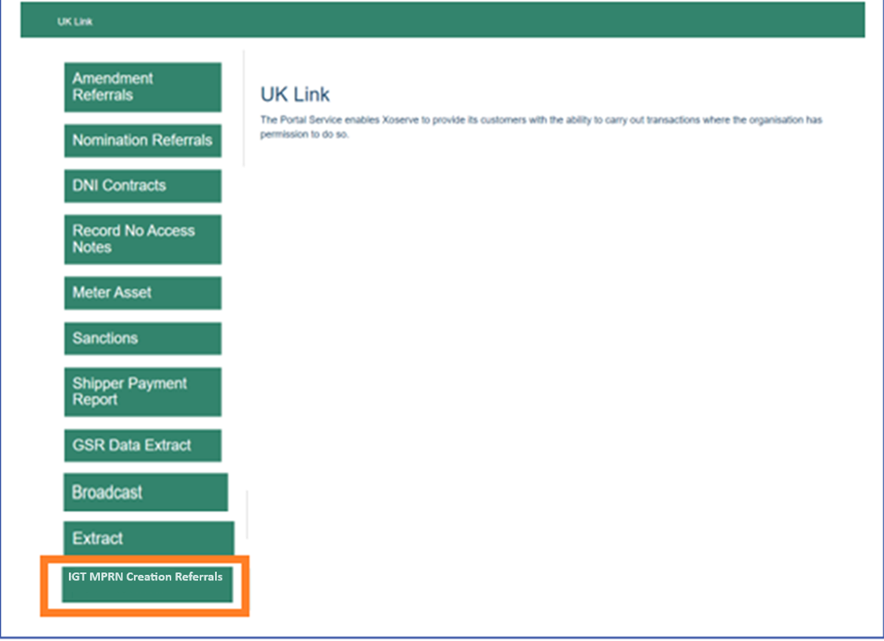
New Screen 1: A new screen “Select IGT Referrals”, will include an option to filter referrals by LDZ. When first arriving on the page, the filter will default to “All” but no results are shown until the ‘Search’ button is selected.

On providing the LDZ filter option and selecting “Search”, the system will provide the required details in a tabular format to the user. The requests will be batched to an internal “Batch ID” to uniquely identify the referral requests and associate them to the IGT IMC request.

The list will be sorted by default on the ‘Referral action by date’ column to see which referrals are closer to the SLA deadline and require action sooner. Referrals will be approved automatically if DNOs do not make a decision within the SLA of 2 full working days. (After 9pm on the 2nd day, subject to batch processing)

There will also be the option to search by the directly connected CSEP ID column. The user can type in a CSEP ID and the results will be narrowed to display only matching entries.

The table on this screen will include the below columns:
- Directly connected CSEP ID
- Batch ID (ID to be made up of the date the referral is received + a unique identifier)
- Directly connected CSEP Site Name
- LDZ
- IGT
- Directly connected CSEP Max AQ
- Directly connected CSEP SHQ
- Referral action by date

The decision on a referral will be confirmed via a ‘Accept’ or ‘Reject’ button below the table. If the request is accepted, the referred MPRNs are made live. If the request is rejected, the MPRN is not made live in the Supply Point Register. When a decision is made, the referral will no longer be visible in the portal.
The user will be shown a message relevant to their decision once submitted. The IGT will be informed by IMR file.

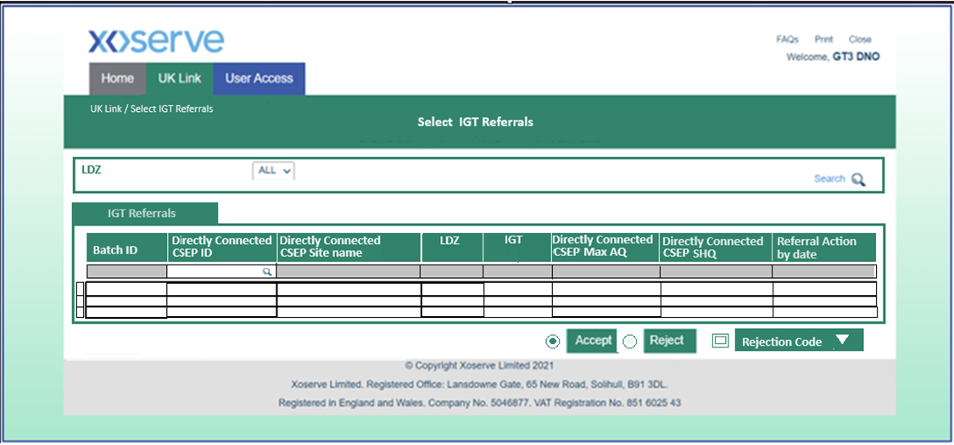
Draft screen, subject to change

New Screen 2: Selecting a referral entry from the table will direct to a new screen “Batch Details”, which will provide some CSEP data and a detailed view of each MPRN requested within this referral.

The top of this page will display the below referral details:
- Directly connected CSEP ID
- Batch ID (ID to be made up of the date the referral is received + unique identifier)
- Sum of referred MPRNs AQ
- Directly connected CSEP Max AQ
- Post approval directly connected CSEP AQ (Calculated at the point of referral)
- Sum of current Meter Points AQ (Sum of all Current Meter points downstream of the directly connected CSEP (Nested + directly connected MPRNs))
- Current Meter Point Count (All Current Meter points downstream of the directly connected CSEP (Nested + directly connected MPRNs))
- Max Meter Point Count
- New Meter Points Referred Count

A further detailed view of the MPRNs associated to this batch request will be presented in a table on this screen with the ability to scroll through.
- MPRN number
- CSEP ID (MPRN is connected to (Nested CSEP))
- Meter Point AQ

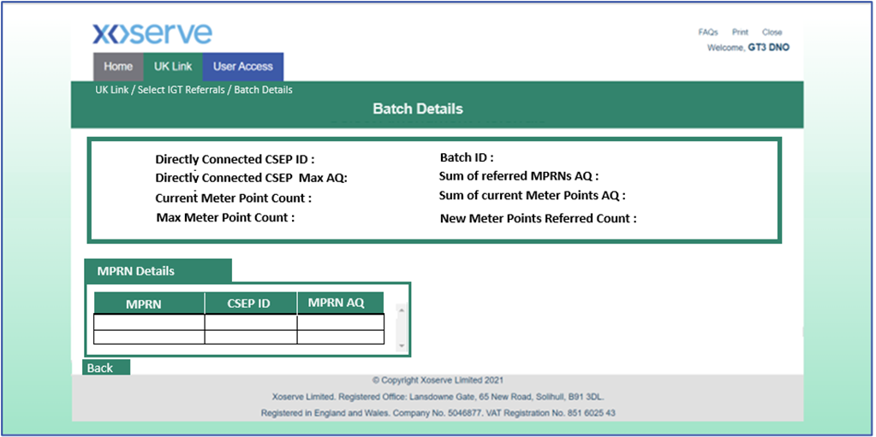
Draft screen, subject to change

Impacted Process:
Where a CSEP has a LDZ and Exit zone change that is being actioned, any MPRN creation requests that need to be referred to DNOs will be automatically rejected, and a rejection IMR notification file will be sent to the submitting IGT. No checks will be made to see if the new LDZ belongs to the same network. This will prevent an outgoing IGT creating MPRNs after the LDZ or exit zone change has been actioned. The request can be resubmitted following LDZ or exit zone change.

Other process points:
- If the DNO approves a referral that will mean the CSEP AQ will breach the Max CSEP AQ. The Max CSEP AQ will not be updated in the system and will continue to be monitored and reported as per BAU. (This applies to directly connected CSEP and the Nested CSEPs).
- If the directly connected CSEP Max AQ is updated by the IGT whilst an MPRN creation request is referred in the portal, the referral will not be removed from the portal until the referral process is complete. The directly connected CSEP Max AQ will be updated and display the live value.
- The new portal screens will match the same permissions for DNOs accessing current portal screens. (e.g. nomination referrals)
- There will be new rejection codes for the IMR file to provide detail around why the DNO has chosen to reject the request.
System automated rejection reasons:
  - IGT00966 - Meter Point creation cannot be progressed due to pending CSEP LDZ change. (New)
  - IGT00965 - Meter Point already in a referral status, creation cannot be progressed. (New)
  - MPO00004 - Duplicate meter point reference found. (Existing- to be reused for duplicate requests received in the IMC file)
  - IGT00967 – Earlier meter point request is still in referral status on this CSEP, new meter point creation cannot be progressed. (New)
Portal dropdown rejection options that will be available to the DN:
  - IGT00968 – CSEP assigned to incorrect DNO. Contact network for information.
  - IGT00969 – Network capacity deemed insufficient. Contact network for information.
  - IGT00970 – Suspected data error in creation request.
  - IGT00971 – CSEP change expected. Contact network for information.

- Once the DNO has accepted a referral and the IMR is sent to IGTs, there will be another validation to ensure the MPRN is not already present at the address. If the MPRN is already present, then the duplicate MPRN creation will be rejected in line with BAU.
- SLA for IMC processing will not be impacted because the response will be sent within the existing SLA of 2 Business days.
- A new allowable value RF (Referred) will be required in C84 segment for IMR file.
- New custom staging table created to store the IGT Referral details. Until MPRNs are accepted and created, they will not be visible in GES and not provided to CSS.
- IGTs to consider the timing of their PSR shipper flows in light of potential impacts.
- There will be an additional IMR file sent to IGTs due to the SLA deadline, the SLA will expire after 9pm and an IMR will be sent after the validations are complete. This means IGT will receive IMR files at 5 instances per day.
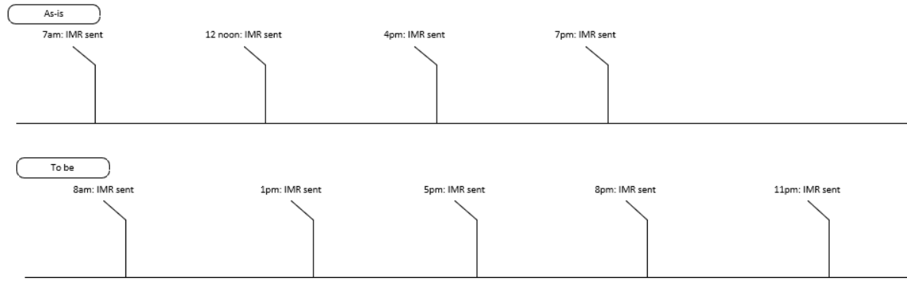
* All timings shown are approximations, and may not be the exact timings

Associated Changes
Associated Change(s) and Title(s):

DSG
Target DSG discussion date: | 19/08/2024
Any further information:

Implementation
Target Release: | Release: Feb 25 – Major release
Status: | For Approval
Cost Range: | Initial Cost estimate at HLSO stage (10/04/24) £350k-£490k  Revised cost range estimate following design completion: £230k-£260k

Industry Response Detailed Design Review
Change Representation
(To be completed by User and returned for response)

Please consider any commercial impacts to your organisation that Xoserve need to be aware of when formulating your response

User Contact Details: | Organisation: | Cadent
User Contact Details: | Name: | Andy Clasper
User Contact Details: | Email: | andy.clasper@cadentgas.com
User Contact Details: | Telephone: | 07884113385
Customer decision on Change Pack: | approved
Commercial impacts: | Limited – although potential through a scenario where additional MPRNs are approved when capacity is not available e.g. site awaiting reinforcement. An internal process will be required to minimise the risk of such occurrence.
Representation Publication: | Publish
Representation Comments: | Cadent accept the proposed change as a method of providing additional control to DNO’s on the number of MPRN’s connecting to a CSEP.  Existing Processes will not change, and this modification will be added to the post acceptance process.  iGT’s would not be able to use this process to increase an AQ/SHQ or meter account above what has been approved through existing connections processes.  In addition, we require an additional data capture field for the DNO connection reference as a unique identifier on the batch details page or the initial iGT referrals page. This is so we can search within our CRM system to locate the relevant connections request and cross reference this against the iGT referral to minimise risk of incorrect approvals and quicken the response for the iGT’s.

Xoserve’ s Response
Xoserve Response to Organisations Comments: | Many thanks for your response and the clarification of the reasoning supporting your decision. With regard to your request for an additional data capture field, this is being reviewed by our Project Team, we will provide a more detailed response to you when I have their update.

Please send the completed representation response to uklink@xoserve.com

Change Representation
(To be completed by User and returned for response)

Please consider any commercial impacts to your organisation that Xoserve need to be aware of when formulating your response

User Contact Details: | Organisation: | Energy Assets Pipelines Ltd / EAP
User Contact Details: | Name: | Michelle Brown
User Contact Details: | Email: | michellebrown@energyassets.co.uk
User Contact Details: | Telephone: | 07538629496
Customer decision on Change Pack: | reject
Representation Publication: | Publish
Representation Comments: | We do not feel that the costs justify the benefits to IGTs

Xoserve’ s Response
Xoserve Response to Organisations Comments: | Many thanks for your response and the reasoning supporting your decision; this feedback is appreciated, we anticipate that the funding aspect of this change will be captured as part of the scheduled discussion of this DDCP at the September ChMC Meeting.

Please send the completed representation response to uklink@xoserve.com

Change Representation
(To be completed by User and returned for response)

Please consider any commercial impacts to your organisation that Xoserve need to be aware of when formulating your response

User Contact Details: | Organisation: | Indigo Pipelines Limited
User Contact Details: | Name: | Cher Harris
User Contact Details: | Email: | cher.harris@sse.com
User Contact Details: | Telephone: | 07747559101
Customer decision on Change Pack: | reject
Commercial impacts: | We remain concerned that the high cost of this change far outweighs the potential benefits, especially given that gas new connections will have ceased in Scotland before April 2027 and England & Wales shortly after
Representation Publication: | Publish
Representation Comments: | The proposed solution needs further consideration as the costs are still too high for the limited potential benefit. We would prefer to continue working with GDNs to review existing CSEPs to identify where reserved capacity can be released.

Xoserve’ s Response
Xoserve Response to Organisations Comments: | Many thanks for your response and the reasoning supporting your decision; this feedback is appreciated, we anticipate that the benefits and funding aspects of this change will be captured as part of the scheduled discussion of this DDCP at the September ChMC Meeting.

Please send the completed representation response to uklink@xoserve.com

Change Representation
(To be completed by User and returned for response)

Please consider any commercial impacts to your organisation that Xoserve need to be aware of when formulating your response

User Contact Details: | Organisation: | Wales & West Utilities
User Contact Details: | Name: | Tom Stuart
User Contact Details: | Email: | tom.stuart@wwutilities.co.uk
User Contact Details: | Telephone: | 07964937739
Customer decision on Change Pack: | approved
Commercial impacts: | No commercial impacts - GDNs receive funding to assess load increases and this will be unaffected as the existing BAU renomination process will continue unchanged. Applications for increased loads still follow the normal process with IGTs submitting details to the DN prior to creation. XRN5616b introduces a way for DNs to assess increases when the correct process has not been followed by the IGT.
Representation Publication: | Publish
Representation Comments: | Thank you for the opportunity to respond to this detailed design change pack - as proposer we approve the change.  As the solution is an exceptions process in addition to the DN/IGT renomination process we anticipate low volumes and believe the 2 day response SLA to approve or reject load increases will be sufficient.  One point of clarity - where the design mentions 'Where a CSEP has a LDZ and Exit zone change that is being actioned' does this mean while a CUN file update is being processed?  To ensure the process is compatible for all DNs, can the ‘GT reference’ be added to the table on screen one

Xoserve’ s Response
Xoserve Response to Organisations Comments: | Many thanks for your response and the clarification of the reasoning supporting your decision; regarding your point of clarity, where a CSEP has a LDZ and Exit zone change that is being actioned ie the IGT submits a CAI file, the CUN file confirming receipt.  With regard to your request for the capture of the GT Reference, this is being reviewed by our Project Team, we will provide a more detailed response to you when I have their update.

Please send the completed representation response to uklink@xoserve.com

Change Representation
(To be completed by User and returned for response)

Please consider any commercial impacts to your organisation that Xoserve need to be aware of when formulating your response

User Contact Details: | Organisation: | BUUK Infrastructure
User Contact Details: | Name: | Kundai Matiringe
User Contact Details: | Email: | Kundai.matiringe@bu-uk.co.uk
User Contact Details: | Reject
Commercial impacts: | Some IGTs are likely to incur additional operational and system costs outside of the costs of the change.
Representation Publication: | Publish
Representation Comments: | This seems more of a data quality issue rather than original issues that the proposer wishes to address and believe that there is more parties can do in order to help improve and add efficiency within the industry. With Gas New Connections expected to cease in the next two years, the business case for this change to go through does not seem to be value for money. Some of the issues identified such of pressure problems lack the evidence to back this up. Unsure the proposed solution is robust enough. It is difficult to understand the benefits of this Change to IGTs. Whilst we support the proposer’s intention, we believe there are other mechanisms to try first to improve and better manage the existing industry processes for capacity management.  There is a potential for anti-competitive behaviour with the proposed solution. The automation of ONJOB flows is also likely to increase the need for operational support. The solution also has a potential to negatively impact IGT Developer customers and in-turn – end -users.

Xoserve’ s Response
Xoserve Response to Organisations Comments: | Many thanks for your detailed response and the reasoning supporting your decision; this feedback is helpful and is appreciated, we anticipate that the funding aspect of this change will be captured as part of the scheduled discussion of this DDCP at the September ChMC Meeting.  In order to improve our understanding ahead of ChMC, are you able to elaborate further on why you believe automation of ONJOBs will lead to a need for additional administrative support and also as to your concern regarding the potential for anti-competitive behaviour?

Please send the completed representation response to uklink@xoserve.com

Change Management Committee Outcome
Change Status: | ☐ Approve | ☐ Reject |  | ☒ Defer
Number of Responses: | 2 approvals, 3 rejected
Design Voting: | ☐ Shipper |  | Please select.
Design Voting: | ☐ National Gas Transmission |  | Please select.
Design Voting: | ☒ Distribution Network Operator |  | Approve
Design Voting: | ☒ IGT |  | Reject
Meeting Date: | 11/09/2024
ChMC Outcome: | As a result of a lack of unanimous approval of the change, Xoserve confirmed that the change cannot progress into delivery. It was agreed that the change is to be placed on hold whilst Xoserve collate information on progress being made by parties on the ongoing data cleansing activity. Xoserve agreed to present an update to December ChMC meeting.

Please send the completed representation response to uklink@xoserve.com

Version Control

Document
Version | Status | Date | Author(s) | Remarks
0.1 | Draft | 07/2024 | Benjamin Snell | Initial Draft

Template
Version | Status | Date | Author(s) | Remarks | Approved By
1.0 | Approved | 09/03/2022 | Rachel Taggart | Detail Design Change Pack transferred to own document | Change Management Committee on 09/03/2022
1.1 | Approved | 25/04/2023 | Rachel Taggart | Updated with new font branding | Emma Smith
1.2 | Updated | 14/08/2023 | Kate Lancaster | Updated with Representation tabs
1.3 | Updated | 25/06/2024 | Richard Hadfield | Updated to add cost range to Implementation section

