Detailed Design Change Pack

Communication detail
Comm Reference: | 3479.1 - VO - KG
Comm Title: | XRN 5940 - Addition of Consumption Adjustment and Updated Meter Readings to initiate an AQ Calculation Month
Comm Date: | 15/06/2026

Change Representation
Action Required: | For Information
Close Out Date: | 29/06/2026

Change Detail
Xoserve reference Number: | XRN 5940
Change Class: | Functional Change
*ChMC Constituency Impacted | Shippers | Distribution Networks | Independent Gas Transporters
Change Owner: | Josie Lewis  uklink@xoserve.com
Background and Context: | This DSC Change Proposal aims to implement CDSP related deliverables in line with those proposed under UNC Modification 0890. This includes incorporating Consumption Adjustment values and Updated Meter Readings into the monthly AQ calculation process. The benefits of this are:  - The central system will calculate a more accurate AQ based on a valid Consumption Adjustment and/or Updated Meter Reading.  - Expected reduction in AQ Corrections as central system will provide agreed logic and reduce customer discretional activities. More accurate AQs held against Supply Meter Points (SMPs)  Shippers have been identified as an impacted party, as they have requested this capability in the related UNC Modification (0890). Networks, including IGTs have also been identified as impacted, as the related industry rules will require the CDSP to include two new triggers in AQ calculation/revision process.  This change includes:  # All site types are intended to be in scope of this change.  # All types of valid accepted updated meter readings for class 2, 3, 4 supply points (Class 1 actual readings cannot be updated).  # All types of valid accepted consumption adjustments for all supply point classes (including any energy adjustments for Telemetered sites)  This change does not include:  # Consumption adjustment reasons ‘isolation’ and ‘duplicate’.  # Changes to Winter Consumption calculation.  # Changes to AQ correction.  #Changes to upstream processes with regards to how consumption adjustments are received in UK Link  #Any consumption adjustments processed outside UK Link

Change Impact Assessment Dashboard
Functional: | Annual Quantity –  - Design will make changes to the existing AQ calculation process for primary reading triggers and introduce a new AQ revision process for secondary triggers i.e. consumption adjustment and updated meter readings  - A new AQ trigger type will be introduced as an internal value to identify all primary and secondary AQ triggers  - New internal failure texts will be introduced to record any AQ revision failures; however, these will not be notified externally  - Design will introduce changes to AQ NRL notification process to ensure the new AQ trigger type is not reported externally via T04 segment  - New AQ methodology code for AQ revision will be introduced for external reporting via the MPRN misuse report sent to PAC  - Changes to internal AQ tools and AQ validation report  Settlement - Changes to PCA interface (energy adjustments for telemetered sites) to record the creation date and time of energy adjustments for secondary trigger validation.  SAP Business Warehouse (BW) - Changes to SAP BW Data source to exclude the new internal AQ trigger type from showing in external DDP Dashboards for AQ corrections.  Reporting –  - Change to several existing internal SAP BO reports to ensure the revised AQ values are also considered for AQ reporting (one of these reports feeds the monthly AQ update pack published on Xoserve.com).  - Changes to existing internal and external SAP ISU reports and processes to include the AQ revision values along with the calculated AQ values in reporting.
Non-Functional: | Monthly AQ review Process Performance  Transaction volume
Application: | SAP ISU  SAP BW/BO  DDP
User(s): | Shippers, Distribution Networks, IGT
Other: | None

Files
File | Parent Record | Record | Data Attribute | Hierarchy or Format Agreed
None | None | None | None | None

Change Design Description
- Introduction

This change is seeking to introduce a new concept of monthly AQ revision whereby if a consumption adjustment or an updated meter reading is received and accepted for a meter point within the AQ submission window (11th of previous month to 10th of current month for Class 3s and 4s, 7th of previous month to 6th of current month for class 1s and 2s), and is considered valid, then the consumption adjustment or updated meter reading is used to revise the current latest AQ. This revised AQ will be effective for the meter point from the 1st of the subsequent month.

The AQ revision process will run alongside the monthly AQ calculation process and will be carried out for only those meter points where there was no primary reading trigger received and where AQ calculation process was not triggered that month.

2.0 ‘To Be’ Process Map

The below process maps (Fig 1 and 2) depict a few examples of how the new AQ triggers i.e. consumption adjustment (CA) and replacement (updated) meter reading will be used to revise the current AQ. Fig 3 depicts how a qualifying read will be used to trigger an AQ calculation.

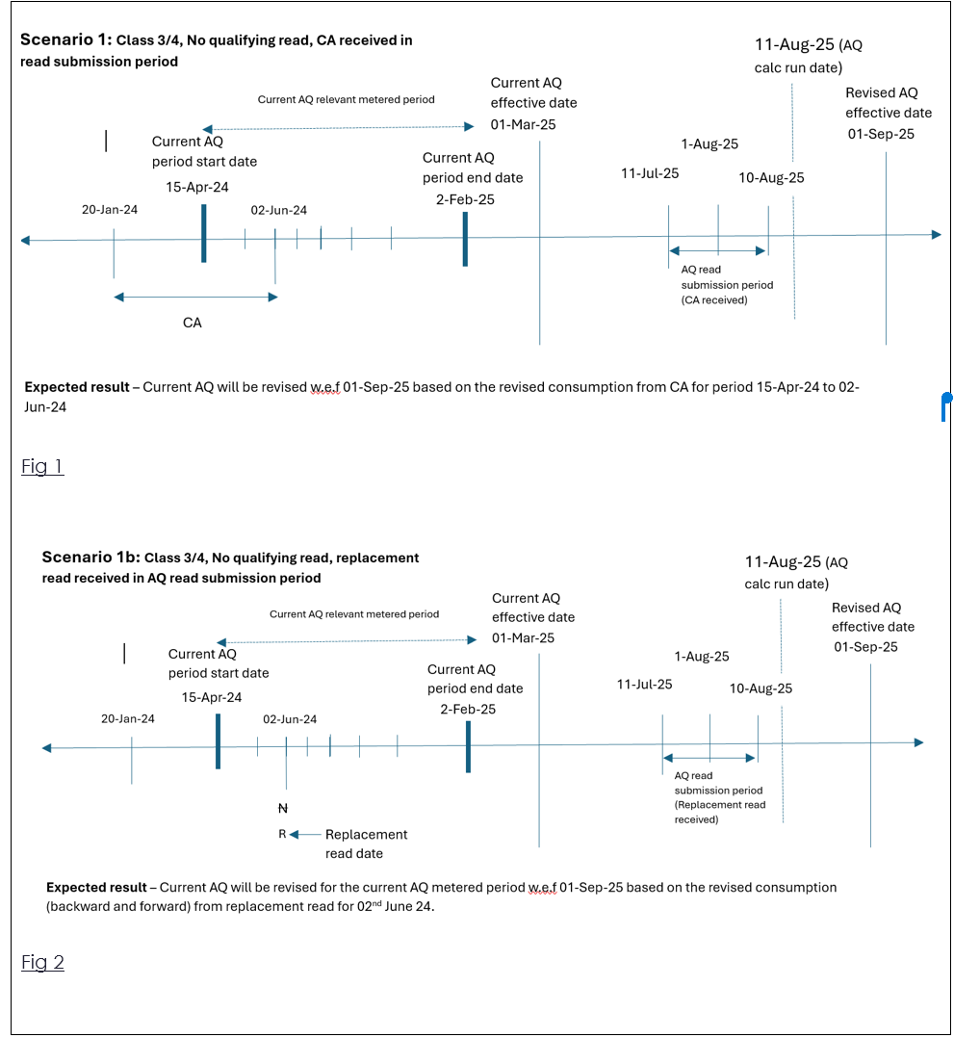

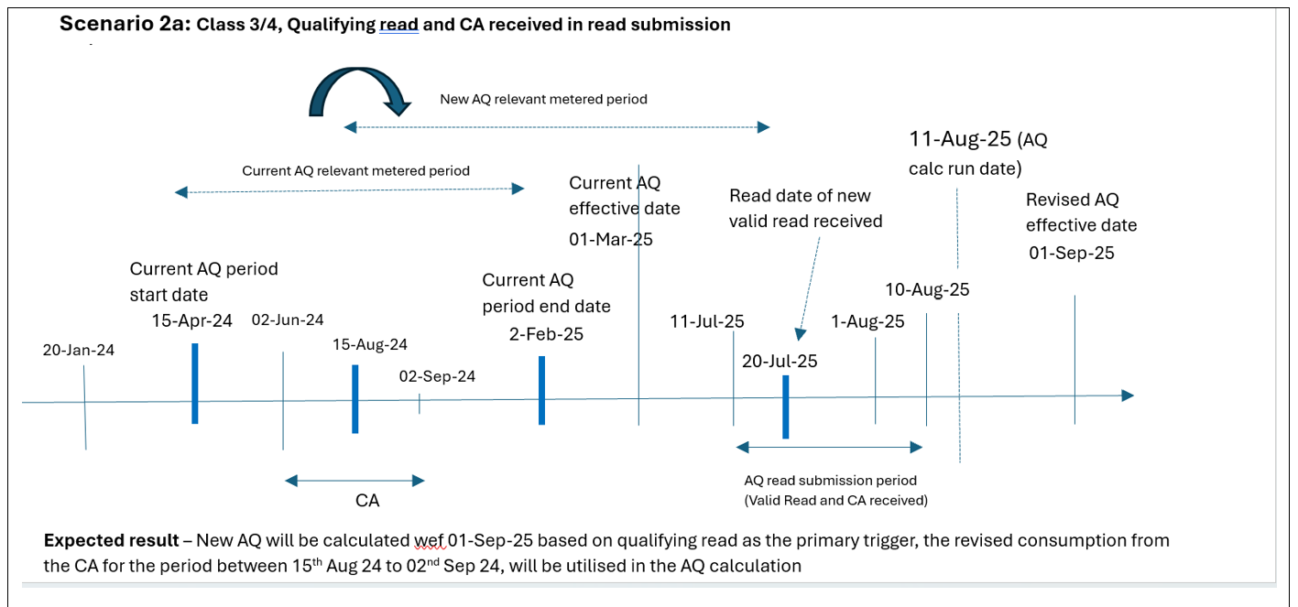

Fig 3

3.0 ‘To Be’ Process Changes

3.1 Changes to monthly AQ calculation process

- AQ calculation process is split into 3 sub processes –
  - Valid AQ trigger data identification and retrieval based on AQ submission window
  - Data Validation and End read determination for AQ process
  - Start read determination and AQ calculation

- Changes will be made to the above AQ sub processes while determining the primary AQ trigger for AQ calculation such that where the latest uploaded reading has either valid accepted consumption adjustment (for class 4 sites) or valid accepted updated meter reading (for class 3 and 4 sites) applied on it, it is still treated as a valid primary trigger for AQ calculation, in addition to the existing BAU primary triggers.

Changes will be made to include a new internal AQ trigger type for AQ calculation process.

3.2 New AQ revision process

- New concept of AQ revision will be introduced, whereby a current AQ is revised for the current AQ relevant metered period (RMP) for the new AQ triggers, as opposed to a new AQ calculation for on a new AQ metered period. AQ will be revised for the current AQ relevant metered period, only where the start and end dates remain the same.

- New AQ revision process will be created to include accepted updated meter readings and accepted consumption adjustments as additional secondary triggers, for only those meter points where a primary trigger is not received within the current AQ submission window.

- New validation checks to ensure only valid accepted consumption adjustments and accepted updated meter readings which fall within the latest AQ relevant metered period are treated as valid triggers for AQ revision.

- New checks to exclude consumption adjustments with ‘Duplicate’ and ‘Isolation’ reasons as valid triggers.

- New validation checks to determine the previous AQ period for the secondary AQ triggers, in case of a SNR (Seasonal Normal review) process.

- Record new internal failure text for AQ revision in certain scenarios (eg: AQ correction etc) within an existing field of the BAU AQ review table as a configurable value. The AQ revision failures will not be notified externally.

- Record new internal AQ trigger type for AQ calculation and AQ revision processes within an existing field of the BAU AQ review table as a configurable value.

- Record a new AQ methodology code (within the existing BAU AQ Operand table) for ‘AQ revision’ which shall be reported within the SAP ISU ‘MPRN misuse report’ issued to PAC.

3.3 Changes to AQ notification process

- Changes will be made to ensure AQ revision failures are not reported via the NRL file (T98). Successful AQ revision values will be reported via the NRL file (T04) and NNL file (A92).

- Changes will be made to the AQ notification (NRL) process to ensure the new internal AQ trigger type is not reported externally to shippers via the T04 segment of NRL file.

- There are no file format changes expected for NRL or NNL notification files.

3.4 Changes to Energy adjustment process for Telemetered sites

Changes will be made to the PCA process to record the creation date and time of energy adjustments received for telemetered sites (within the internal SAP ISU table) so that they can also be treated as secondary triggers for AQ revision, where valid.

3.5 Changes to AQ tools (internal to CDSP)

The below 3 AQ tools are internal tools used to manage and correct any fallouts from the monthly AQ review process and to recalculate the rolling AQ and/or Formula Year AQ (FYAQ) values, where applicable.

- Changes will be made to the BAU AQ correction tool to consider an updated meter read while determining the end trigger read for AQ calculation.

- Changes will be made to the BAU FYAQ Financial Adjustment Decision Tree tool and AQ simulation tool to consider the new secondary triggers for AQ revision during calculation of FYAQ values for class 3 and class 4 sites.

  - Changes to AQ reports (internal and external)

    - Internal:
- Changes will be made to the monthly SAP ISU AQ validation report program (internal) to include the AQ revision checks in addition to the current AQ calculation validation steps.

- Changes will be made to several internal SAP BO reports’ filters to ensure AQ revision values are also considered along with the calculated AQ values based on AQ trigger type.

- Changes will be made to a few internal SAP ISU reports (eg: SNR assurance reports) to include the AQ revision values along with the calculated AQ values.

    - External:
- Changes will be made to the SAP BO Monthly AQ performance statistics report which feeds the external monthly AQ update pack published on Xoserve.com, to ensure AQ revision values are also included along with AQ calculations.

Changes will be made to the external SAP ISU MPRN Misuse report issued to PAC to include the new AQ methodology code for AQ revision (shown below).

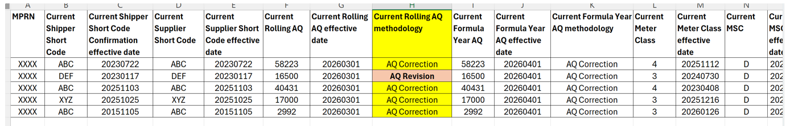

3.7 SAP BW Data Source Objects

- Changes will be made to one of the SAP BW AQ Data source objects to exclude the new internal AQ trigger type from showing in external DDP Dashboards for AQ corrections.

3.8 DDP Dashboards

- The DDP reports and dashboards will show the revised/calculated AQ values for the existing and new triggers.
- The AQ revision failures will not be visible on any DDP reports/dashboards.

4.0 Detailed Design

4.1 Multiple AQ triggers

In case of multiple AQ triggers received within the same AQ submission window, the primary reading trigger will be identified first to trigger an AQ calculation, be it successful or failed. Only where a primary trigger is not received for a meter point, UK Link will look for the presence of a secondary trigger i.e. accepted updated meter reading and/or consumption adjustment, in this order, to trigger an AQ revision.
AQ calculation or AQ revision will be triggered only once for a meter point in case of multiple AQ triggers received within the same AQ submission window.

- Where multiple primary triggers are present for the same meter point within the AQ submission window, the latest reading (based on read date and created date) will be used to trigger an AQ calculation.
- Where multiple secondary triggers are present for the same meter point, the latest updated meter reading (based on read date) will be used to trigger an AQ revision. Where an updated meter reading is not present, the latest consumption adjustment (based on adjustment end date) will be used to trigger an AQ revision.

4.2 Validation checks on AQ revision triggers

The secondary triggers will be used for AQ revision only where they are valid, as below:

- The read date of the updated meter reading should fall within the latest AQ RMP i.e. an updated meter reading is valid if the read date is greater than or equal to the latest AQ relevant metered period (RMP) start date and less than or equal to the latest AQ RMP end date.
- The consumption adjustment (CA) period should fall (partially/fully) within the latest AQ RMP i.e. a CA trigger is not valid where the adjustment end date is less than or equal to the latest AQ RMP start date or the adjustment start date is greater than or equal to the latest AQ RMP end date.
- The adjustment reason for a consumption adjustment should not be due to ‘isolation’ or ‘duplicate’.

4.3 AQ revision failures

Where a valid secondary AQ trigger is present, the AQ revision is treated as a failure in the below cases:
- Current AQ is due to an AQ correction – As there is no latest AQ RMP due to the presence of an AQ correction, AQ will not be revised.
- Current AQ is due to Seasonal Normal Review and there is no previous AQ RMP - As there is no current or previous AQ RMP, AQ will not be revised.
- The AQ revision start date is not the same as the original AQ RMP start date.
- Where a current AQ calculation period isn’t available (eg: due to a greenfield site or archival rules etc), AQ will not be revised on receipt of a valid secondary trigger as there is no AQ RMP for which AQ needs to be revised.
- AQ revision can also fail due to an existing BAU failure, although the probability would be less.

These failure notifications will be recorded for internal purposes but not notified externally.

4.4. AQ revision in case of Seasonal Normal Review (SNR)

Where a valid CA or updated meter reading is received within the AQ submission window, and the current AQ is derived using the Seasonal Normal Review (SNR) process, the previous AQ RMP is used for validating the secondary AQ triggers and where valid, AQ is revised for the previous AQ RMP.

4.5. AQ revision notification

- Where an AQ revision is successful, the revised AQ value will be notified to the shippers and networks (and IGTs) via the NRL and NNL files.
- Where an AQ revision is not successful (due to the new failure scenarios mentioned in 4.3 or due to an existing BAU failure), no notification will be issued to the shippers.

Below is an example of how a successful AQ revision record would appear in the T04 segment of NRL file and A92 segment of NNL file.

Refer Fig 2 Scenario 1b,

"T04","XXXXXXXXX","","WS","WA2",XXXXX,XXXXXXXXXX,"XXXX","XXX","XXXXXXXXXXXXX",
"",6,"LI",1.02264022640,"N",1.000,1,"N",73274,71300,20250901,20240415,20250202, 32482","38740","",,-
3,20250915,,,695,,20200501,79770,587,"26810","33383",20250401,,,,"","A","TC",20251001, "01","XXXXXXXX","NDMA",20231119,20241105

"A92",XXXXXXX,4,"","WS","XXXX","XXX",73274,71300,20250901,695,,,,"XXXXXX",XXXXX, 20
251001,"01",,,,""

Note – A calculated AQ value for a primary trigger will still be notified via NRL/NNL files, be it successful or failed as per BAU process.

4.6 AQ trigger type

A new AQ trigger type will be recorded using an existing field (AQ correction reason code) within UK Link AQ review table for internal purposes. This trigger type will be used to identify the primary and secondary triggers which resulted in an AQ calculation or revision. This trigger type will not be notified in any external files or reports.

AQ Trigger | Description
95 | AQ Calculation Cyclic Read or Daily Energy Trigger
96 | AQ Calculation CA Trigger
97 | AQ Calculation Updated Read Trigger
98 | AQ Revision CA Trigger
99 | AQ Revision Updated Read Trigger

4.7 Additional scenarios
4.7.1 Vacant sites:
- If an updated meter reading is received for a vacant site for a read date before the vacancy start date, the read will not trigger the vacancy exit. The subsequent AQ revision triggered by such an updated meter reading will also not trigger vacancy exit.
- If an updated meter reading is received for a vacant site for a read date during the vacancy period (i.e. the reading may have triggered exit on receipt), the updated meter reading will be used as a potential trigger for AQ revision, in the absence of a primary trigger.

4.8 AQ impacts to downstream processes

Where AQ is revised for a meter point due to a secondary trigger, the revised AQ will be used in the downstream processes as per BAU (the below list is not a finite list of processes):

- EUC assignment/re-assignment
- Class 1 Threshold crosser notification - Class 1 Threshold crosser flag (T97) and Class 1 Threshold crosser count (T04) within the NRL file would still apply to a successful AQ revision (in line with MOD0691S eligibility criteria)
- Correction Factor Update - The process of determining the CORRECTION_FACTOR_REQUIRED flag (T97) and the associated MOD681s rules would be applied to an AQ revision similar to an AQ calculation.
- Meter Reading Frequency update
- Priority Consumer Tolerance notification
- Emergency Contact details notification
- Offer revision
- Formula Year AQ snapshot

5.0 Volumetrics

Based on last 7 months volumetrics, the number of AQ calcs every month is expected to increase by 40-45k (0.3%) due to the inclusion of the 2 new triggers. As the number of current AQ calcs processed every month is approx. 16 to 17 mn, this increase is not expected to have any effects on the AQ notification (NRL/NNL) file size to shippers or DNs.

Performance of the current AQ calculation/revision process may be impacted due to the changes and increase in the number of AQ calcs.
Performance testing will be carried to determine impacts to the monthly AQ processes, BAU processes and downstream systems.

6.0 Change Impact Assessment Summary

XRN5940 is a high complexity AQ change impacting several UK Link processes, components and systems e.g. SAP ISU, SAP BW, DDP and GES. Testing will include functional, regression and performance testing of all impacted processes and systems.

Below is a heat map depiction of the impacted areas for this change.

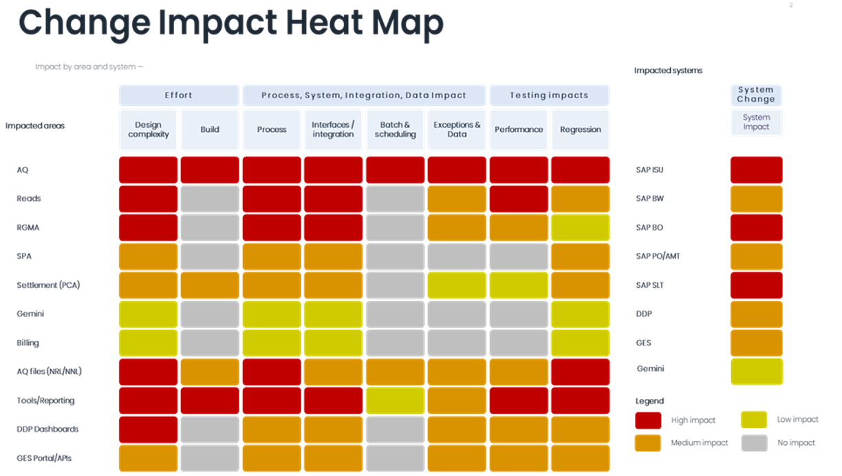

Associated Changes
Associated Change(s) and Title(s): | N/A

DSG
Target DSG Discussion Date: | Monday 22nd June 2026
Any further information: | N/A

Implementation
Target Release: | November 2026 Major Release – Implementation Date currently being assessed and will be discussed with customers in July DSC Change Management Committee
Status: | Approved.

Industry Response Detailed design

«RangeStart:HDS»
Change Representation

Please consider any commercial impacts to your organisation that Xoserve need to be aware of when formulating your response

User Contact Details: | Organisation: | «h1_organisation»
User Contact Details: | Name: | «h1_name»
User Contact Details: | Email: | «h1_email»
User Contact Details: | Telephone: | «h1_telephone»
Customer decision on Change Pack: | «h1_userDataStatus»
Commercial impacts: | «h1_commercial_impacts»
Representation Publication: | «h1_consultation»
Representation Comments: | «h1_userDataComments»

Xoserve’ s Response
Xoserve Response to Organisations Comments: : | «h1_xoserveResponse»

Please send the completed representation response to uklink@xoserve.com

«RangeEnd:HDS»

Version Control

Document
Version | Status | Date | Author(s) | Remarks

Template
Version | Status | Date | Author(s) | Remarks | Approved by
1.0 | Approved | 09/03/2022 | Rachel Taggart | Detail Design Change Pack transferred to own document | Change Management Committee on 09/03/2022
1.1 | Approved | 25/04/2023 | Rachel Taggart | Updated with new font branding | Emma Smith
1.2 | Updated | 14/08/2023 | Kate Lancaster | Updated with Representation tabs | N/A
1.3 | For Approval | 21/07/2025 | Kate Lancaster | Updated branding | To be approved by ChMC

